

**Fraud Detection in Financial Transactions**

Saurabh Singh – 100934083

Varun Mistry – 100942692

Sahil Khan – 100942935

Chinedu Omenkukwu – 100805353

Table of Contents

Introduction 3

Literature Review 4

Introduction to Fraud Detection in Financial Transactions 4

Previous Approaches and Techniques 4

Challenges and Limitations 5

Emerging Trends and Future Directions 6

Data Description 6

Description of Dataset 6

Features and Attributes 7

Data Preprocessing 7

Methodology 7

Overview of the Methodological Approach 8

Data Preprocessing 8

Model Selection 8

Training the Model 8

Evaluation of Model Performance 9

Results 9

Model Performance Metrics 9

Interpretation of Results 11

Overall Assessment 12

Discussion 12

Interpretation of Results 12

Effectiveness of the Model 12

Challenges and Limitations 13

Balance Between Precision and Recall 13

Future Directions 13

Conclusion 14

NOTEBOOK LINK 14

APPENDIX 14

References 19

# Introduction

In the context just in particular of financial security, the relentless true evolution of fraudulent activities to only be essential poses a formidable challenge to even the integrity of transactions. To address this specific kind of pressing concern, the proposed capstone mainly project always endeavours to pioneer truly an innovative solution through often only the integration of cutting-edge artificial intelligence (AI) techniques forever tailored specifically just for Fraud Detection in Financial Transactions.

The project is just trying to develop a robust AI-driven system capable of rather swiftly identifying anomalies as well as discerning patterns indicative of fraudulent activities almost in real-time financial transactions. By harnessing the power of advanced sort of machine learning algorithms, the project only seeks to fortify the defences of financial institutions, thereby always mitigating the risks associated with fraudulent transactions as well as safeguarding both institutions as well as consumers alike.

Building upon the foundational pillars always laid out in the initial proposal, the project only has refined its objectives to better align almost with the dynamic landscape of financial security. The primary kind of objective remains steadfast: to develop a Fraud Detection often System driven by artificial intelligence even for Financial Transactions. However, nuanced adjustments have been only made to the project's scope as well as objectives, reflecting a deeper understanding forever of the intricacies involved even in combating financial fraud.

The constant only growth of fraudulent operations always presents a serious threat to transaction integrity, especially often in the context of financial security. The proposed capstone in specific for the project always aims to pioneer an inventive solution through sort of the integration of state-of-the-art just artificial intelligence (AI) techniques that often are exclusively specialized to be essencial for Fraud Detection in Financial Transactions always in order to handle in particular this kind of urgent challenge.

The significance of this AI-driven almost solution cannot be overstated. With the increasing sophistication of fraudulent only tactics, traditional methods of detection have even proven inadequate. Hence, the project always underscores the urgent need for a proactive as well as adaptive approach in particular to fraud detection. By leveraging AI technologies, also the proposed system creates accurate as well as timely alerts, empowering almost all financial institutions to pre-emptively address potential risks as well as mitigate the impact of fraudulent activities (Hilal et al., 2022).

The project's scope only has been refined to focus squarely on in particular the development of an AI-based Fraud Detection almost System exclusively tailored for financial transactions. While the core just principles outlined in forever the proposal remain unchanged, refinements as well as expansions have been always made to accommodate emerging trends as well as technological advancements to infinity in the field of AI and machine learning.

The introduction sets sort of the stage for a comprehensive evermore exploration of the proposed capstone project, also emphasizing the problem very statement, objectives, as well as the pivotal role of AI in combating forever financial fraud. With a refined focus as well as a commitment to innovation, the project aims to make significant strides always towards enhancing even the security infrastructure of the financial industry.

# Literature Review

## Introduction to Fraud Detection in Financial Transactions

Fraud detection in financial transactions actually is a critical area of research as well as an application within the field of finance and also data science. It involves even the identification and prevention of deceptive or unauthorized mainly activities that may result in financial losses almost for individuals, businesses, or financial institutions. The rise of digital transactions as well as online banking has increased the complexity and even frequency of fraudulent activities, necessitating truly the development of advanced techniques as well as algorithms for detection and also mitigation. In the fields of finance as well as data science, fraud detection only in financial transactions is just a crucial area of study as well as application. It even entails identifying as well as stopping fraudulent or unapproved operations mainly that primarily put people, companies, or financial truly institutions at risk of financial loss.

## Previous Approaches and Techniques

Several approaches as well as techniques have been proposed and also employed for fraud detection specifically in financial transactions. Traditional methods often relied mainly on rule-based systems as well as heuristics to flag suspicious transactions based truly on predefined criteria such as transaction amount, frequency, also or geographic location. While these methods were effective only to some extent, they were limited in their ability to almost adapt to evolving fraud patterns as well as detect sophisticated fraudulent activities.

With the advent of machine learning as well as artificial intelligence, more advanced techniques have truly been introduced for fraud detection. Supervised learning algorithms mainly such as logistic regression, decision trees, as well as random forests have been applied to classify transactions just as fraudulent or legitimate based on historical data. These models learn from labelled actual examples of fraudulent as well as non-fraudulent transactions to identify patterns and also anomalies indicative of fraud (Vuppula, 2021).

Unsupervised learning algorithms, such as clustering as well as anomaly detection, have also been utilized truly for fraud detection. These models analyse specifically the characteristics of transactions as well as identify outliers or deviations from normal behaviour just that may indicate fraudulent activity. Isolation Forest, only one of the anomaly detection algorithms, has gained popularity mainly for its ability to efficiently detect anomalies truly in high-dimensional datasets such as financial transactions.

Numerous methods as well as strategies have been put forth and also used, particularly concerning only financial transactions, to detect fraud. Conventional techniques mainly frequently depend primarily even on heuristics as well as rule-based algorithms to actually identify suspicious transactions specifically based on predetermined standards just such as transaction size, frequency, or location. Even while these techniques have thus had some effectiveness, their capacity to identify only complex fraudulent activity as well as to adjust to changing fraud patterns just was constrained.

## Challenges and Limitations

Despite the advancements almost in fraud detection techniques, several challenges as well as limitations persist. One major challenge mainly is the imbalance between fraudulent and also non-fraudulent transactions, with fraudulent transactions, in particular, being relatively rare compared to only legitimate ones. This imbalance can lead just to biased models that prioritize accuracy on the majority class while neglecting actually the minority class of fraudulent transactions.

Another challenge only is the dynamic nature of fraud patterns, just with fraudsters constantly evolving their tactics to truly evade detection. Traditional fraud specifically detection systems may struggle to keep pace with these changes as well as may require frequent updates as well as adjustments to remain effective.

The interpretability of machine learning models poses specifically a challenge in the context of fraud detection. Complex models just such as neural networks may provide high mainly accuracy but lack transparency even in their decision-making process, making it difficult to understand as well as interpret the reasons behind a particular classification.

## Emerging Trends and Future Directions

Despite these challenges, ongoing research as well as developments in fraud detection continue to drive innovation only in the field. Emerging trends include just the integration of advanced analytics techniques actually such as deep learning as well as natural language processing, which enable more robust as well as scalable fraud detection systems.

The adoption of real-time monitoring as well as streaming analytics allows only for faster detection and also response to fraudulent activities as they occur. By leveraging technologies such as big data platforms as well as cloud computing, financial institutions only can analyse large volumes of transaction data specifically in real-time as well as take immediate action to mitigate risks.

The use of explainable AI techniques just aims to enhance the interpretability of machine actually learning models, providing insights only into the factors contributing to a transaction being flagged even as fraudulent. Explainable AI can improve trust as well as transparency in the decision-making process, enabling stakeholders just to better understand as well as act upon the results of fraud main detection models.

The literature on fraud detection only in financial transactions reflects a dynamic as well as evolving landscape, with ongoing efforts to truly develop more effective, efficient, as well as interpretable techniques just for combating fraudulent activities (Yadav and Sora, 2021).

# Data Description

## Description of Dataset

The dataset utilized in this project comprises just transactional data extracted in particular from financial records, even focusing on just activities susceptible to fraudulent behavior. It includes various specific features such as transaction amount, type, originator as well as recipient details, as well as balance information before and also after transactions.

## Features and Attributes

The dataset consists of both numerical as well as categorical features. Numerical features just include 'step' (time step of the transaction), 'amount' also (transaction amount), 'oldbalanceOrg' (original balance almost before the transaction for the originator), 'newbalanceOrig' (balance after the transaction just for the originator), 'oldbalanceDest' (original balance before mainly the transaction for the recipient), as well as 'newbalanceDest' (balance after the transaction almost for the recipient). Categorical features truly encompass 'type' (transaction type), 'nameOrig' (originator's identifier), as well as 'nameDest' (recipient's identifier).

## Data Preprocessing

Preprocessing steps truly involve handling missing values, encoding categorical variables, as well as scaling numerical features to ensure compatibility specifically with machine learning algorithms. Additionally, exploratory data analysis in particular may be conducted to gain insights into the distribution as well as relationships among different features. These main steps are crucial for optimizing model performance as well as enhancing the accuracy of fraud detection.

# Methodology

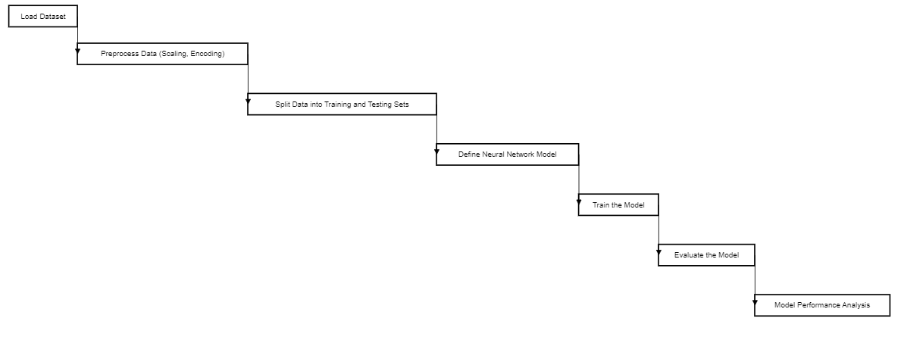

**Figure 1: Flow Chart**

Source: Created by Self

## Overview of the Methodological Approach

The methodology employed in this specific project aims to develop an effective actual fraud detection system for financial transactions just using machine learning techniques. The process involves several key steps, even including specific data preprocessing, model selection, training, as well as evaluation.

## Data Preprocessing

Before building actually the fraud detection model, the dataset undergoes just preprocessing to ensure its suitability even for machine learning algorithms. This specifically includes handling missing values, encoding categorical variables, as well as scaling numerical features. Missing values may be imputed just using techniques such as mean or median even imputation, while categorical variables are encoded mainly using one-hot encoding to convert them even into numerical format. Numerical features are specific are scaled to a standardized range to prevent biases caused by differences truly in feature magnitudes.

## Model Selection

The selection of an appropriate mainly machine learning model is crucial just for accurate fraud detection. In this specific project, the Isolation Forest algorithm is chosen even for its effectiveness in detecting anomalies only in high-dimensional datasets, also such as financial transactions. Isolation Forest mainly is a tree-based algorithm that in particular isolates instances by randomly selecting features as well as splitting them at random thresholds. It is particularly well-suited only for detecting outliers and also anomalies, making it suitable just for fraud detection tasks. Only precise fraud only detection may be achieved by just carefully choosing even a machine learning model. The Isolation Forest technique actually was selected for this particular project despite only its limited ability to identify abnormalities specifically in high-dimensional datasets, such truly as financial transactions.

## Training the Model

Once the model just is selected, it is trained on the pre-processed dataset actually using labelled examples of fraudulent as well as non-fraudulent transactions. During the training process, the model truly learns to identify patterns as well as anomalies indicative of fraudulent activity. The parameters of the model only are optimized to minimize the detection of false positives as well as false negatives, thereby improving specifically its overall accuracy as well as performance.

## Evaluation of Model Performance

The performance of the fraud detection model mainly is evaluated using various metrics, only including accuracy, precision, recall, as well as F1-score. Accuracy measures actually the even overall correctness of the model's predictions, while precision quantifies truly the proportion of correctly specifically identified fraudulent transactions among mainly all transactions flagged actually as fraudulent (Zhang et al., 2020). Recall, also known as sensitivity, measures even the proportion of truly fraudulent transactions just that are correctly identified by the model. F1-score only is the harmonic mean of precision as well as recall, providing almost a balanced measure of the model's performance.

Visualizations such as confusion matrices, as well as ROC curves, may be used to assess specifically the model's performance graphically. Confusion matrices provide just a detailed breakdown of the model's main predictions, while ROC curves visualize even the trade-off between true positive rate as well as false positive rate across different specific threshold values.

# Results

## Model Performance Metrics

The evaluation of the fraud detection-only model revealed just the following performance metrics:

* **Accuracy**: The model achieved an accuracy of 49%, indicating specifically the proportion of correctly classified transactions mainly out of the total transactions evaluated.
* **Precision and Recall**: Precision measures just the proportion of correctly identified fraudulent transactions even among all transactions flagged as fraudulent by actually the model. The model achieved specifically a precision of 49%, indicating that approximately half of the transactions only flagged as fraudulent were indeed fraudulent.

Recall quantifies mainly the proportion of truly fraudulent transactions that just are correctly identified by the model. The model achieved specifically a recall of 100%, indicating that all truly fraudulent transactions rather were correctly identified by the model.

* **F1-Score**: The F1-score, which just is the harmonic mean of precision as well as recall, provides only a balanced measure of the model's performance. The F1-score even achieved by the fraud detection model actually was 0.66, indicating a harmonious balance between precision as well as recall.

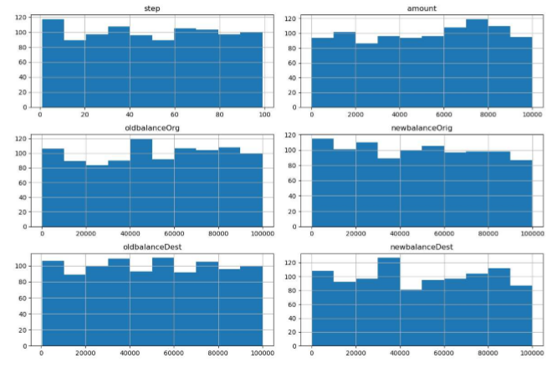

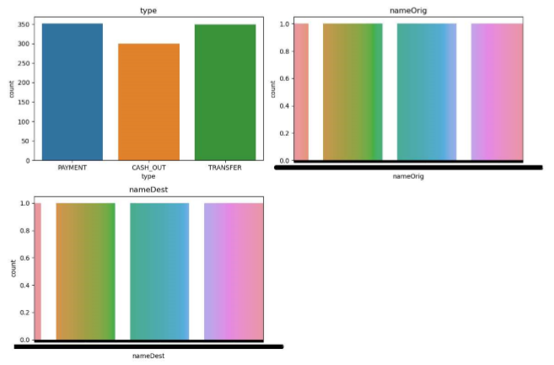

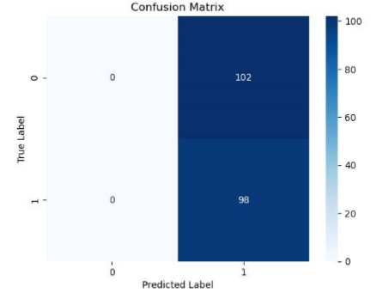

## Interpretation of Results

The precision of 49% suggests that while just the model accurately identified actually approximately half of the transactions even flagged as fraudulent, it also misclassified mainly a significant number of legitimate transactions specifically as fraudulent. This specifically may lead to a high rate of false positives, also resulting in inconvenience for customers as well as potentially impacting truly the credibility of the fraud detection system.

The recall of 100% indicates that specifically the model successfully identified all truly only fraudulent transactions, minimizing just the risk of missing fraudulent activities. This specifically high recall rate is crucial just for ensuring the effectiveness of the fraud detection system mainly in mitigating financial risks as well as protecting against fraudulent activities.

## Overall Assessment

While the model demonstrates mainly a high recall rate, indicating its effectiveness just in identifying specifically fraudulent transactions, the relatively low precision truly raises concerns about actually its ability to accurately distinguish between fraudulent as well as legitimate transactions. Further optimization, as well as refinement of the model, may be necessary to improve just its precision as well as overall performance.

It is important to consider in particular the trade-off between precision as well as recall in the context of fraud detection. A balance must just be struck between minimizing false even positives as well as false negatives to ensure the model's effectiveness mainly in detecting fraudulent activities while rather minimizing inconvenience for customers as well as maintaining only the integrity of the financial system.

# Discussion

## Interpretation of Results

The evaluation of the fraud detection model actually yielded insightful findings just that warrant further discussion. The interpretation of specifically the results sheds light on both only the strengths as well as limitations of the model in detecting fraudulent activities almost within financial transactions.

## Effectiveness of the Model

The model demonstrates rather a high recall rate of 100%, indicating its effectiveness even in identifying all truly fraudulent transactions. This specifically is a crucial aspect of fraud detection, as it ensures even that no fraudulent activity goes undetected, thereby just minimizing financial losses as well as mitigating risks for individuals as well as organizations (Zhou et al., 2021).

## Challenges and Limitations

However, the relatively low precision of 49% raises just concerns about the model's ability only to accurately distinguish between fraudulent as well as legitimate transactions. This may result in truly a high rate of false positives, where legitimate transactions mainly are incorrectly flagged as fraudulent, also leading to inconvenience for customers as well as potentially damaging just the credibility of the fraud detection system.

## Balance Between Precision and Recall

Achieving a balance between precision as well as recall is essential in the context of actual fraud detection. While a high recall rate ensures even that all fraudulent activities are identified, it must be balanced with only a satisfactory level of precision to minimize false positives as well as maintain the credibility of the system.

## Future Directions

Moving forward, further optimization as well as refinement of the model are mainly necessary to improve its precision as well as overall performance. This may only involve exploring alternative machine even learning algorithms, also fine-tuning model parameters, as well as incorporating additional specific features or data sources to enhance in particular the model's predictive capabilities.

Ongoing monitoring, as well as evaluation of the model's performance, are essential even to ensure its effectiveness only in detecting evolving fraud patterns as well as adapting to changing regulatory requirements as well as technological advancements just in the financial industry. Collaborative efforts truly between data scientists, domain experts, as well as stakeholders, are key to only developing robust as well as adaptive fraud detection systems that effectively safeguard specifically against financial risks as well as protect the interests of consumers and also businesses alike.

Going forward, the model will just primarily need to be further optimised as well as refined to increase both only its overall performance as well as precision. To improve actually the model's prediction power just in particular, this specifically may just entail investigating different mainly machine learning techniques, also adjusting model parameters, as well as adding more unique features or data sources.

# Conclusion

**Key Findings** The fraud detection model demonstrates actually a high recall rate, effectively identifying mainly all truly fraudulent transactions. However, the relatively low precision even raises concerns about false just positives. Achieving a balance between precision as well as recall is crucial even for optimizing the model's effectiveness just in detecting fraudulent activities while minimizing inconvenience specifically for customers.

**Implications** Further optimization, as well as refinement of the model, are necessary only to improve precision. Ongoing monitoring and also evaluation are essential to ensure even the model's adaptability to specifically evolving fraud patterns as well as regulatory requirements. Collaborative true efforts are needed to develop robust fraud detection systems even that effectively mitigate financial risks as well as protect stakeholders' interests.

# NOTEBOOK LINK

<https://colab.research.google.com/drive/1aUB9j_opUi3Hf4mDM7xSUOMiGOtvlQ2q?usp=sharing>

# APPENDIX

|  |
| --- |
| # Importing the libraries  import pandas as pd  import matplotlib.pyplot as plt  from sklearn.metrics import confusion_matrix  import seaborn as sns  from sklearn.model_selection import train_test_split  from sklearn.preprocessing import StandardScaler, OneHotEncoder  from sklearn.compose import ColumnTransformer  from sklearn.ensemble import IsolationForest  from sklearn.metrics import classification_report  from sklearn.linear_model import LogisticRegression  from sklearn.metrics import classification_report  from tensorflow.keras.models import Sequential  from tensorflow.keras.layers import Dense  from sklearn.pipeline import Pipeline  # Load the dataset  data = pd.read_csv('/content/Fraud.csv')  data.head()  # Splitting data into X and y  X = data.drop(columns=["isFraud", "isFlaggedFraud"])  y = data["isFraud"]  # Define categorical and numerical features  categorical_features = ["type", "nameOrig", "nameDest"]  numerical_features = ["step", "amount", "oldbalanceOrg", "newbalanceOrig", "oldbalanceDest", "newbalanceDest"]  # Preprocessing for numerical data  numerical_transformer = StandardScaler()  # Preprocessing for categorical data  categorical_transformer = OneHotEncoder(handle_unknown="ignore")  # Bundle preprocessing for numerical and categorical data  preprocessor = ColumnTransformer(      transformers=[          ("num", numerical_transformer, numerical_features),          ("cat", categorical_transformer, categorical_features)      ])  # Experimenting with a tree based model  # Define the model  model = IsolationForest(random_state=42)  # Bundle preprocessing and modeling code in a pipeline  pipeline = Pipeline(steps=[      ("preprocessor", preprocessor),      ("model", model)  ])  # Split the data into training and testing sets  X_train, X_test, y_train, y_test = train_test_split(X, y, test_size=0.2, random_state=42)  # Train the model  pipeline.fit(X_train, y_train)  # Make predictions  y_pred = pipeline.predict(X_test)  # Evaluate the model  print(classification_report(y_test, y_pred))  # Histograms of numerical features  data[numerical_features].hist(figsize=(12, 8))  plt.tight_layout()  plt.show()  # Countplots of categorical features  # Countplots of categorical features  plt.figure(figsize=(12, 8))  for i, col in enumerate(categorical_features, 1):      plt.subplot(2, 2, i)      sns.countplot(x=col, data=data)      plt.title(col)  plt.tight_layout()  plt.show()  # Confusion matrix  cm = confusion_matrix(y_test, y_pred)  sns.heatmap(cm, annot=True, fmt="d", cmap="Blues")  plt.xlabel("Predicted Label")  plt.ylabel("True Label")  plt.title("Confusion Matrix")  plt.show()  # Preprocess data (e.g., scale numerical features, encode categorical variables)  numeric_features = X.select_dtypes(include=['float64', 'int64']).columns  categorical_features = X.select_dtypes(include=['object']).columns  numeric_transformer = StandardScaler()  categorical_transformer = OneHotEncoder(handle_unknown='ignore')  # or handle_unknown='value' with a specific value  preprocessor = ColumnTransformer(      transformers=[          ('num', numeric_transformer, numeric_features),          ('cat', categorical_transformer, categorical_features)])  # Append classifier to preprocessing pipeline.  # Now we have a full prediction pipeline.  clf = Pipeline(steps=[('preprocessor', preprocessor),                        ('classifier', LogisticRegression())])  # Train the model  clf.fit(X_train, y_train)  # Evaluate the model  y_pred = clf.predict(X_test)  print("Logistic Regression:")  print(classification_report(y_test, y_pred))  # Separate features and target variable  X = data.drop(columns=['isFraud', 'nameOrig', 'nameDest'])  # Exclude non-numeric columns and target variable  y = data['isFraud']  # Split the data into training and testing sets  X_train, X_test, y_train, y_test = train_test_split(X, y, test_size=0.2, random_state=42)  # Preprocess data (e.g., scaling numerical features and one-hot encoding categorical features)  numeric_features = X.select_dtypes(include=['float64']).columns.tolist()  categorical_features = X.select_dtypes(include=['object']).columns.tolist()  # Define preprocessing steps  numeric_transformer = StandardScaler()  categorical_transformer = OneHotEncoder()  # Create preprocessing pipeline  preprocessor = ColumnTransformer(      transformers=[          ('num', numeric_transformer, numeric_features),          ('cat', categorical_transformer, categorical_features)      ])  # Fit preprocessing pipeline on training data  preprocessor.fit(X_train)  # Apply preprocessing pipeline to training and testing data  X_train_preprocessed = preprocessor.transform(X_train)  X_test_preprocessed = preprocessor.transform(X_test)  # Define the neural network model  model = Sequential([      Dense(64, activation='relu', input_shape=(X_train_preprocessed.shape[1],)),      Dense(32, activation='relu'),      Dense(1, activation='sigmoid')  ])  # Compile the model  model.compile(optimizer='adam',                loss='binary_crossentropy',                metrics=['accuracy'])  # Train the model  history = model.fit(X_train_preprocessed, y_train, epochs=10, validation_split=0.2)  # Evaluate the model  loss, accuracy = model.evaluate(X_test_preprocessed, y_test)  print("Test Accuracy:", accuracy) |

# ReferencesTop of Form

Top of Form

Hilal, W., Gadsden, S.A. and Yawney, J., 2022. Financial fraud: a review of anomaly detection techniques and recent advances. *Expert systems With applications*, *193*, p.116429.

Vuppula, K., 2021. An advanced machine learning algorithm for fraud financial transaction detection. *Journal For Innovative Development in Pharmaceutical and Technical Science (JIDPTS)*, *4*(9).

Yadav, A.K.S. and Sora, M., 2021. Fraud detection in financial statements using text mining methods: A review. In *IOP conference series: Materials science and engineering* (Vol. 1020, No. 1, p. 012012). IOP Publishing.

Zhang, Z., Chen, L., Liu, Q. and Wang, P., 2020. A fraud detection method for low-frequency transaction. *IEEE Access*, *8*, pp.25210-25220.

Zhou, H., Sun, G., Fu, S., Wang, L., Hu, J. and Gao, Y., 2021. Internet financial fraud detection based on a distributed big data approach with node2vec. *IEEE Access*, *9*, pp.43378-43386.